[YOUR PROJECT NAME]
Analysis Model

Submitted to:

Asst. Prof. Ma. Rowena C. Solamo
Faculty Member
Department of Computer Science
College of Engineering
University of the Philippines, Diliman

Submitted by:
[List of Members in Alphabetical Order]

In partial fulfillment of Academic Requirements
for the course
CS 191 Software Engineering I
of the
1st Semester, AY <YYYY-YYYY>
Revision Control

History Revision:
Revision Date | Person Responsible | Version  Number | Modification
10/20/2016 | Kyle Rosales | 1.0 | Initial document, list of boundaries, controllers, and entities

Purpose:

[Place purpose of the document here.]

Audience:

[Place the description of the people who will be reading this document.]
System Name: [Name of the System eg. Athlete Record Maintenance System]

Description: [Brief Description of the System in 3-7 sentences.]

Class Diagram:

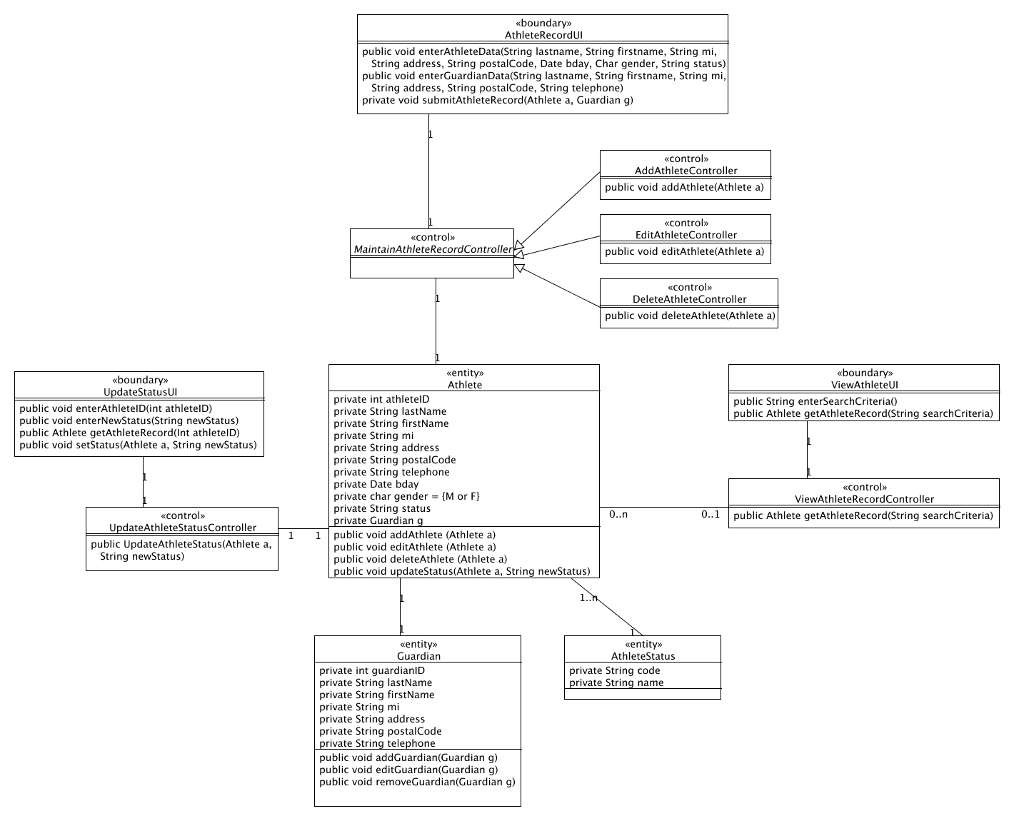

Boundary Classes:

Class Name | Description
ViewScheduleUI
CreateMeetupScheduleUI
ManageUserUI

Control Classes:

Class Name | Description
ViewScheduleController
EditScheduleController
CreateMeetUpScheduleController
ManageUserController
AddUserController
DeleteUserController
EditUserController

Entity Classes:

Class Name | Description
Admin
User
Schedule
MeetUpSchedule

